Assignment 2. latitude and longitude filter

The black curves show the mean (2) and median (3), one advantage of applying the median filter is that it is less affected by the outliners. The grey curve shows the raw measured trajectory (1).

Disadvantages with the mean filter is that it introduces lag and is sensitive to outliners.

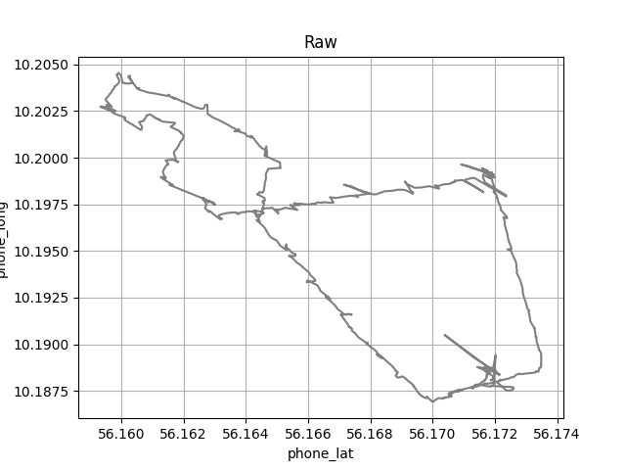

Figur 1

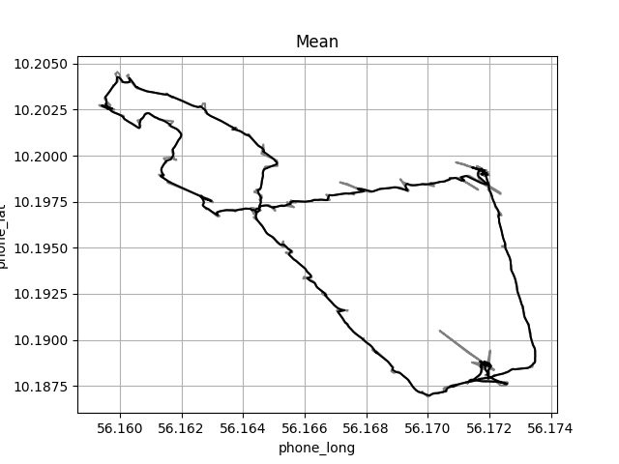

Figur 2

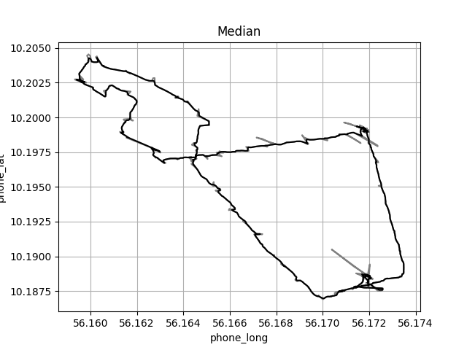

Figur 3